How to sign up your child for DragonFly Max or Update their information:

In order for your child to be eligible under the MHSAA eligibility rules for all sports and activities a PARENT must sign their up on DragonFly Max and complete ALL sections listed. Please follow these steps:

- Visit www.dragonflymax.com, click Login/Sign-Up.

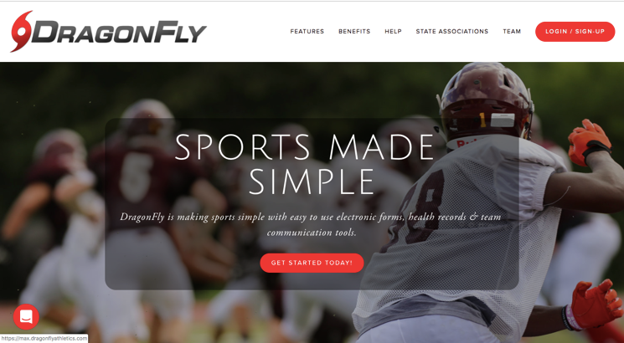

- Login if you registered your child in 2019, and skip to step 10. If you are moving from the New Hope Middle School or transferring from another MHSAA member school, go to SELECT ANOTHER SCHOOL and enter SHEGU3 for the school code.
- If your child is new to New Hope or activities, click "Sign Up for Free".
- Follow the prompts to create your Parent Account with your email address or phone number. The parents name goes in the FIRST NAME & LAST NAME fields.

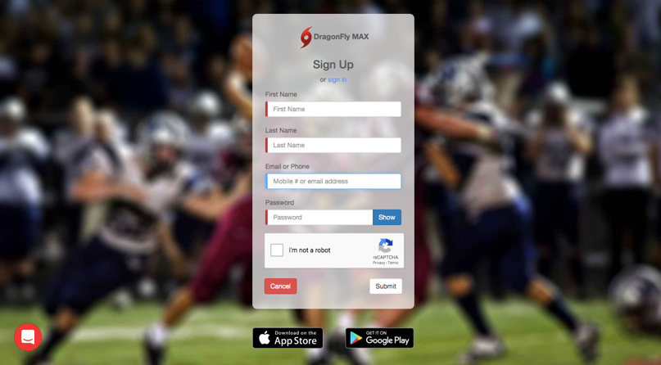

- Confirm the name is correct and click IT’S ME on the pop-up box.
- A Verification ID will be sent to either your text messages or email (check your JUNK email box). Enter the code when prompted and click ACCEPT the terms of agreement.
- On the next page click on GET STARTED icon, then click the PARENT icon.
- Enter your child's School Code (SHEGU3) when prompted and click GO. Check to ensure you’re are joining New Hope High School and JOIN.
- Click ADD A CHILD and type your CHILD’S NAME in the appropriate fields and click NEXT. You will be prompted to re-enter the School Code (SHEGU3). Choose the sport(s) or activity(ies) your child wishes to participate in and click ADD A Child.
- You will be directed back to your Home Screen and your child’s name and icon will appear. Click on the icon to get started.
- On your child’s Home Screen, scroll down to the GET STARTED icon at the bottom of the page.
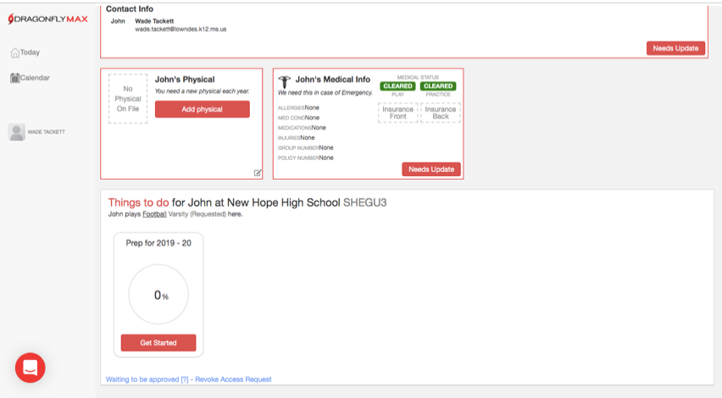
- You must complete these next forms for your child to be eligible, starting with the UPDATE MEDICAL & DEMOGRAPHIC INFO FOR 2020-2021.
- There are 8 sections in this category; All sections must be completed in this category before moving on.
- If you completed any of the sections in previous years, your information should be saved and a new signature and date is all that is required.
- Your child’s coach and the athletic department will complete the Physical Examination Form section once we receive a copy of you child’s physical form signed by a physician.
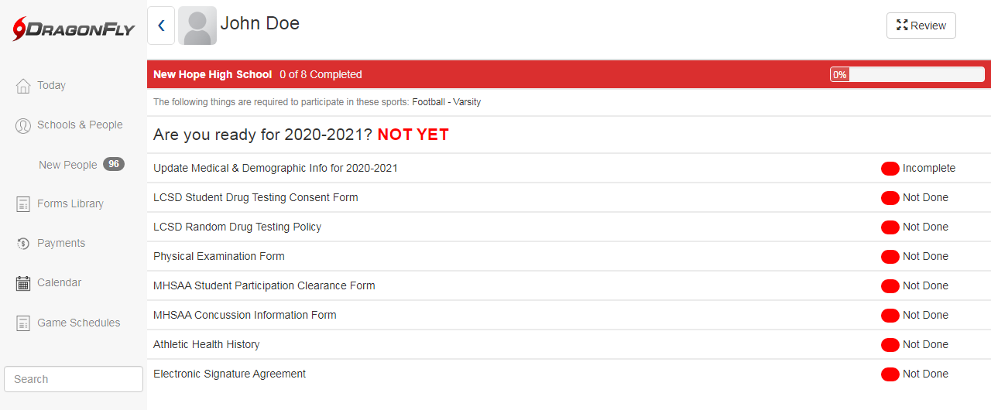
- Your child is required to complete the NFHS Sportsmanship Certificate on their own. They can do this at school with the help of a coach or teacher, or at home. (https://nfhslearn.com/courses/37000/sportsmanship). Once the course is complete, take a screenshot of the Certificate and Upload the screenshot. This is not required if your child has previously completed the course.
- After completing your child's forms, you can review his/her profile OR add another child's profile.

